**Smoke test- file organizer – problems, bugs:**

1. Connection to Dropbox is not available:

* Go to file organizer app
* Go to ‘Sources’
* Go to ‘+’ icon
* Select ‘Dropbox’
* Enter sign in details
* Click on ‘Allow’’ >>>>> blank page opens, with no available view. When done clicked, user is to sources section. Screenshot attached.

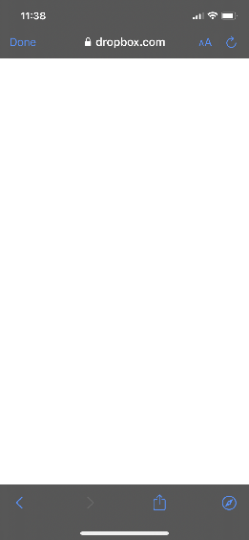

1. Connection to One is not available:

* Go to file organizer app
* Go to ‘Sources’
* Go to ‘+’ icon
* Select ‘One Drive’
* Enter sign in details
* One Drive icon on the sources meniu appears
* Click on the icon >>>>>> an error occured, LiveServicesErrorDomain error 5.

1. After clicking on privacy policy agree button, not clear how to go back to questions:

* Go to file organizer app
* Go to ‘Sources’
* Go to ‘Web’
* Schroll down to ‘ Our Privacy Policy‘
* Click agree >>>>>> not clear how to go back to questions or main meniu.

1. After clicking 'Do not show me again' hamburger meniu button becomes inactive:

* Go to file organizer app
* Go to ‘Sources’
* Go to ‘Web’
* Go to hamburger icon
* Tick ‘Do not show me again’
* Click ‘ OK‘ >>>>>> hamburger meniu button becomes inactive.

1. Files can only be inported from iCloud drive or files folder:

* Go to file organizer app
* Go to ‘Files’
* Go to ‘Import’
* Go to ‘Browse‘ >>>>Files can only be picked up from 3 folders (iCloud Drive, files, downloads folders). No possibility to attached images from photos folder or other locations.

1. Audio and video play on repeat and has to be stopped manually:

* Go to file organizer app
* Go to ‘Files’
* Go to ‘Audios’
* Click on Audio >>>> Audio plays on repeat, has to be stopped manually. Same with video play.

1. Files can not be edited:

* Go to file organizer app
* Go to ‘Files’
* Select ‘Edit’ >>>> restriction sign appears on all files, edit function is not available.

1. When extract audio is selected, application crashes:

* Go to file organizer app
* Go to ‘Files’
* Go to Videos‘
* Click on information icon on the right hand side of video
* Select ‘Extract Audio‘ >>>>> application crashes.

**Functional checklist - file organizer – problems, bugs:**

1.Connection to Dropbox is not available:

* Go to file organizer app
* Go to ‘Sources’
* Go to ‘+’ icon
* Select ‘Dropbox’
* Enter sign in details
* Click on ‘Allow’’ >>>>> blank page opens, with no available view. When done clicked, user is to sources section. Screenshot attached.



2.Connection to One is not available:

* Go to file organizer app
* Go to ‘Sources’
* Go to ‘+’ icon
* Select ‘One Drive’
* Enter sign in details
* One Drive icon on the sources meniu appears
* Click on the icon >>>>>> an error occured, LiveServicesErrorDomain error 5.

3. Only 20 web tabs can be opened:

* Go to file organizer app
* Go to ‘Sources’
* Go to ‘Web’
* Click on double window
* Click on add another web window
* Add as many windows as possible >>>>20 web windows can be added.

4. Invalid Web page can be set as Homepage:

* Go to file organizer app
* Go to ‘Sources’
* Go to ‘Web’
* Click on function button
* Select ‘Set as Home page‘ >>>>>> invalid Web page set as Homepage.

5. Bookmarks search does not work:

* Go to file organizer app
* Go to ‘Sources’
* Go to ‘Web’
* Click on Bookmark icon
* Enter word in search tab >>>> no results filtered out, existing list of bookmarks can be seen.

6. Invalid credentials can be entered in Bookmank search field:

* Go to ‘Sources’
* Go to ‘Web’
* Click on Bookmark icon
* Enter invalid credentials in search field >>>>user does not get any message. For example – no results.

7. After clicking 'Do not show me again' hamburger meniu button becomes inactive:

* Go to file organizer app
* Go to ‘Sources’
* Go to ‘Web’
* Go to hamburger icon
* Tick ‘Do not show me again’
* Click ‘ OK‘ >>>>>> hamburger meniu button becomes inactive.

1. After entering invalid web details or format, user does not get any message:

* Go to file organizer app
* Go to ‘Sources’
* Go to ‘Web’
* Enter invalid Web address or format >>>>> user does not get any message.

1. Mail link with non existing Web page can be sent:

* Go to file organizer app
* Go to ‘Sources’
* Go to invalid web address
* Click on functions button
* Select ‘Mail link to this page’ >>>>> non existing Web link received by email.

10. Mail link to this page can be sent to non existing email:

* Go to file organizer app
* Go to ‘Sources’
* Go to ‘Web’
* Click on functions button
* Select ‘Mail link to this page’
* Enter non existing email address
* Click send >>>> link sent to non existing email.

11. Mail link can be sent with big numbers of inputs in subject field:

* Go to file organizer app
* Go to ‘Sources’
* Go to ‘Web’
* Click on functions button
* Select ‘Mail link to this page’
* Enter big numbers of inputs in subject field
* Click send >>>> link sent with big numbers of inputs in subject field.

12. Files can only be inported from iCloud drive or files folder:

* Go to file organizer app
* Go to ‘Files’
* Go to ‘Import’
* Go to ‘Browse‘ >>>>Files can only be picked up from 3 folders (iCloud Drive, files, downloads folders). No possibility to attached images from photos folder or other locations.

13. Audio and video play on repeat and has to be stopped manually:

* Go to file organizer app
* Go to ‘Files’
* Go to ‘Audios’
* Click on Audio >>>> Audio plays on repeat, has to be stopped manually. Same with video play.

14. Big number of inputs can be used, once name is saved, does not fit into the tab:

* Go to file organizer app
* Go to ‘Files’
* Click on ‘Options‘
* Click ‘Rename‘
* Select file and enter big number of inputs is name field >>>> name saved, name does not fit into the tab.

15 . Rename files with numbers, symbols, punctuation marks only:

* Go to file organizer app
* Go to ‘Files’
* Click on ‘Options‘
* Click ‘Rename‘
* Select file and enter numbers, symbols, punctuation marks only >>>> file name saved.

1. Not clear how to delete files:

* Go to file organizer app
* Go to ‘Files’
* Select ‘Edit’ >>>> restriction sign appears on all files. Restriction sign need to be clicked, then delete option appears in the right hand side. This function is not clear and hard to find. Same situation with recordings and videos.

1. Delete more than one file at the same time is not possible:

* Go to file organizer app
* Go to ‘Files’
* Go to ‘Options’
* Select ‘Edit’>>>> only one file can be deleted at the time.

1. Only one file can be shared at the same time:

* Go to file organizer app
* Go to ‘Files’
* Click on file information icon
* Select ‘Open in‘
* • Select option where file will be shared >>>>only one file can be shared at the same time.

1. Only one file can be emailed at the same time:

* Go to file organizer app
* Go to ‘Files’
* Click on file information icon
* Select ‘Email‘ >>>>> only one file can be emailed at the same time.

1. Only one folder can be zipped at the same time:

* Go to file organizer app
* Go to ‘Files’
* Click on folder information icon
* Select ‘Zip‘ >>>> only one folder zipped at the same time.

1. When extract audio is selected, application crashes:

* Go to file organizer app
* Go to ‘Files’
* Go to Videos‘
* Click on information icon on the right hand side of video
* Select ‘Extract Audio‘ >>>>> application crashes.

1. Tagged images, cannot be opened in files folder on the phone:

* Go to file organizer app
* Go to ‘Files’
* Choose file and click on information icon on the right hand side
* Select ‘Open in’
* Select ‘Add tags’
* Select type and colour of the tag
* Click ‘Done’
* Go to Files folder on your phone
* Find tagged file and try to open it >>>>>> file is impossible to open.

1. Application does not go to background when incoming call or text message come:

* Open application
* Incoming call comes >>>> application stays in foreground.
* Incoming text message comes >>>> application stays in foreground

**Non functional checklist - file organizer – problems, bugs:**

1. Flickering tabs in Files section:

* Go to file organizer app
* Go to ‘Files’ >>>> bottom tab is flickering. Screenshot attached.

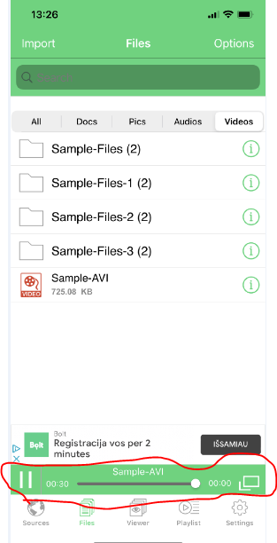

1. Some icons on the playlist are not clear:

* Go to file organizer app
* Go to ‘Files’
* Go to ‘Playlist‘
* Select ‘Video‘ >>>>>playlist opens, some icons on the playlist is not clear. Tooltips or instructions need to be added. Screenshot attached.

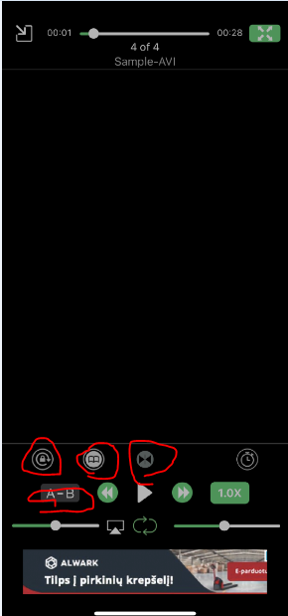

**New features, improvements:**

1. Too many adverts while using application – this amount could be reduced.
2. Import files from more phone locations could be added. For example - Photo library.
3. For some icons tooltips could be added.
4. Change language could be added.
5. Screen rotation could be added.